LAB NO: 5 INTRODUCTION TO FLEX
Name: Ketan Goud
Reg No: 220905260
Section: D D2
Roll No: 39

1. Count the number of vowels and consonants in the given input.

%{
#include <stdio.h>
#include <string.h>

int chars = 0;
int vowels = 0;
int consonants = 0;
%}

%%
[aAeEiIoOuU]+ {
vowels += strlen(yytext);
chars += strlen(yytext);
}
\n {
chars++;
}
[a-zA-Z] {
consonants++;
chars++;
}
. {
chars++;
}
%%

int main(int argc, char **argv)
{
yylex();
printf("\nCharacters: %d, Vowels: %d, Consonants: %d\n", chars, vowels, consonants);
return 0;
}

int yywrap() {
return 1;
}

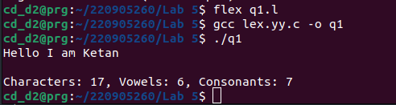

2. Count the number of words, characters, blanks and lines in a given text.

%{
#include <stdio.h>
#include <string.h>

int chars = 0;
int words = 0;
int lines = 0;
%}

%%
[a-zA-Z]+ {
words ++;
chars += strlen(yytext);
}
\n {
chars++;
lines++;
}
. {
chars++;
}
%%

int main(int argc, char **argv)
{
printf("Enter text:\n");
yylex();
printf("\nCharacters: %d, Words: %d, Lines: %d\n", chars, words, lines);
return 0;
}

int yywrap() {
return 1;
}

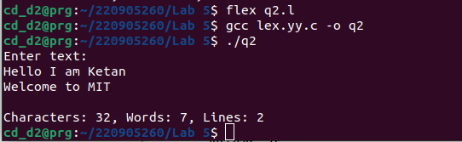
3. Find the number of positive integer, negative integer, positive floating positive number and negative floating point number

%{
#include <stdio.h>
#include <string.h>

int pos_int = 0;
int neg_int = 0;
int pos_float = 0;
int neg_float = 0;
%}

%%
[0-9]+ {
pos_int++;
}
[-][0-9]+ {
neg_int++;
}
[0-9]+[.][0-9]+ {
pos_float++;
}
[-][0-9]+[.][0-9]+ {
neg_float++;
}
\n {
}
. {
}
%%

int main(int argc, char **argv)
{
printf("Enter text:\n");
yylex();
printf("\nPositive Integers: %d, Negative Integers: %d, Positive Floats: %d, Negative Floats: %d\n", pos_int, neg_int, pos_float, neg_float);
return 0;
}

int yywrap() {
return 1;
}

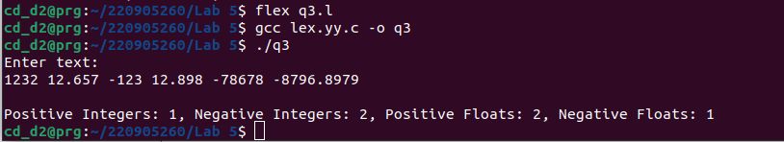

4. Given a input C file, replace all scanf with READ and printf with WRITE statements also find the number of scanf and printf in the file.

%{
#include <stdio.h>
#include <string.h>

int printf_count = 0;
int scanf_count = 0;
%}

%%
"printf" {
printf_count++;
fprintf(yyout, "WRITE");
}
"scanf" {
scanf_count++;
fprintf(yyout, "READ");
}
\n {
fprintf(yyout, "\n");
}
. {
fputc(yytext[0], yyout);
}
%%

int main(int argc, char **argv)
{
FILE *input_file = fopen(argv[1], "r");
FILE *output_file = fopen(argv[2], "w");
yyin = input_file;
yyout = output_file;
yylex();
fclose(input_file);
fclose(output_file);
printf("\nPrintf count %d, Scanf count %d\n", printf_count, scanf_count);
return 0;
}

int yywrap() {
return 1;
}

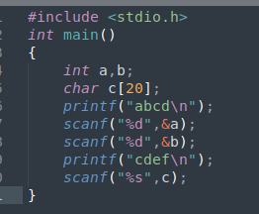

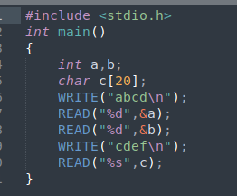

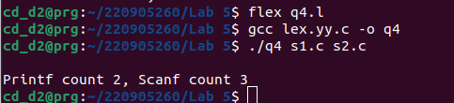

5. That changes a number from decimal to hexadecimal notation.

%{
#include <stdio.h>
#include <stdlib.h>
int decimal = 0;
%}

%%
[0-9]+ {
decimal = atoi(yytext);
printf("Decimal: %d, Hexadecimal: %X\n", decimal, decimal);
}
[ \t\n]+ ;
. {
}
%%

int main()
{
printf("Enter decimal numbers:\n");
yylex();
return 0;
}

int yywrap() {
return 1;
}

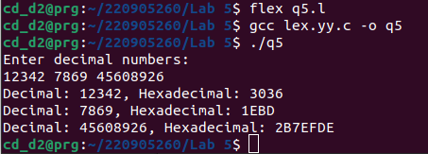

6. Convert uppercase characters to lowercase characters of C file excluding the characters present in the comment.

%{
#include <stdio.h>
#include <string.h>
#include <ctype.h>
char word;
%}

%%
"//".* {
fprintf(yyout, "%s", yytext);
}

"/*"([^*]|\*+[^*/])*\*+"/" {
fprintf(yyout, "%s", yytext);
}
[A-Z] {
printf("%s",yytext);
word=tolower(yytext[0]);
fputc(word,yyout);
}
\n {
fprintf(yyout, "\n");
}
. {
fputc(yytext[0], yyout);
}
%%

int main(int argc, char **argv)
{
FILE *input_file = fopen(argv[1], "r");
FILE *output_file = fopen(argv[2], "w");
yyin = input_file;
yyout = output_file;
yylex();
fclose(input_file);
fclose(output_file);
printf("\n");
return 0;
}

int yywrap() {
return 1;
}
